[Experiment 3] Manufacturing Process Design Efficiency Evaluation Task Instructions
1. Experiment Overview
- Task Name: Evaluation of Manufacturing Process Design Efficiency based on GDP (Generative Digital-twin Prototyper)
- Objective: To verify the practical utility of the system by comparing the design time required for manual tasks versus utilizing GDP AI features for the same manufacturing specifications.

2. Experiment Method and Procedure
This experiment involves performing the following two methods sequentially and measuring the total time taken for each.
- CASE A. Manual Design: Users manually input data and arrange the layout using GDP's editing functions.
- CASE B. AI-Assisted Design (GDP-assisted): Users input natural language specifications into the GDP AI Assistant to automatically generate the model and integrate tools.

3. Evaluation Task Scenario
- Scenario Name: High-end E-Bike Assembly Simulation Line
- Task Goal: To create a digital twin prototype within GDP based on provided process specifications and improve the line to meet the target production output (100 UPH).

4. Process Specifications
Configure the process table and 3D layout based on the specifications below.
Task Description and Resource Specs | Cycle Time
Frame Loading & Alignment: Two workers manually position and align the frame on the conveyor. | 20 sec
Drive Unit (Motor/Pedal) Assembly: One 6-axis articulated robot places and assembles the drive unit onto the body. | 30 sec
Battery & Wiring: One skilled worker fixes the battery pack and manually connects the precise internal wiring. | 45 sec
Wheel Set Integration: Front and rear wheels are integrated simultaneously using one robot and a dedicated automation jig (Machine). | 25 sec
Steering & Brake Setting: Two workers adjust the handlebar clearance and brake status at a manual station. | 40 sec
Final Inspection & Packaging: One dedicated inspection machine with vision sensors performs the final exterior and functional check. | 20 sec

5. Instructions
Task 1 (Initial Setup): Generate a 6-step serial BOP based on the specifications above.
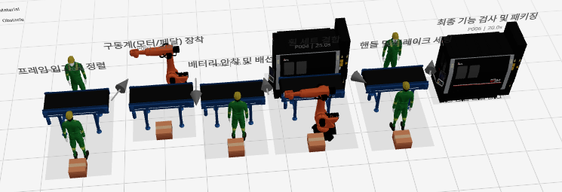
Task 2 (Line Optimization):
1. Analyze the current line's UPH and parallelize the bottleneck process to satisfy the Target UPH of 100.
2. Generate an enclosure surrounding the entire line to ensure protection and secure the safety zone.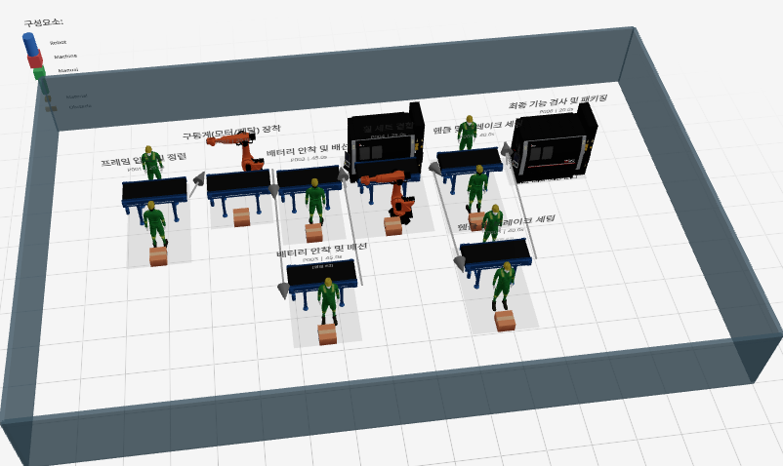

6. Result Sheet
Category | Start Time | End Time | Elapsed Time (Min/Sec)
CASE A. Manual Design
CASE B. AI-Assisted Design

